Protect Our Young Ones Social Media Toolkit

Some families may struggle with the decision to have their children ages 5-11 vaccinated with the COVID-19 vaccine. #DYK that children are as likely to be infected with #COVID19 as adults? They can get very sick, have potential short or long-term complications, and spread it to others at home and school.

Learn from Solomon and Miigis (Anishinaabe) of Duluth, Minnesota why they made the important decision to have their daughter vaccinated https://youtu.be/5ZJbYu-74dA. #ProtectTheOnesYouLove by getting vaccinated. #NativesStopTheSpread
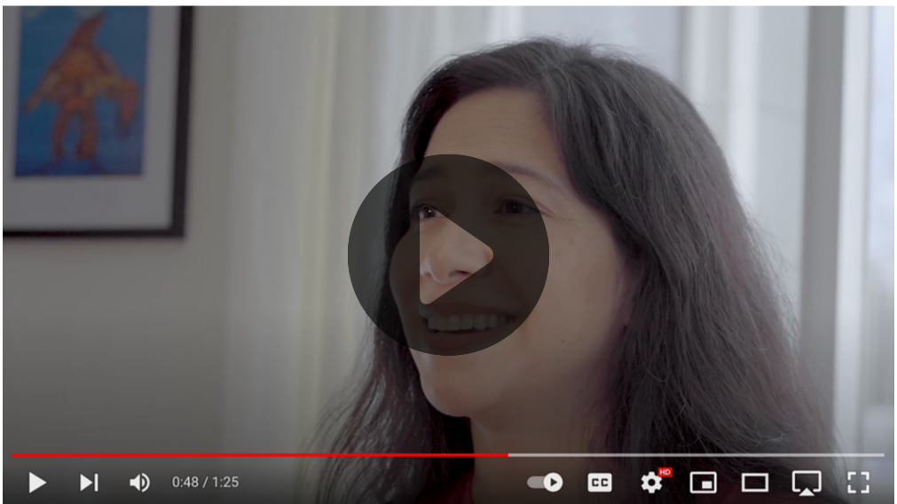
Partners to tag:
@Anthctoday @Aaipdocs @CDCgov @HealthyNativeYouth @HonoringNations @IndianCountryToday @_IllumiNatives @IndianHealthBoard_Minneapolis @IndianHealthService@Indianz @JohnsHopkinsSPH @NationalIndianHealthBoard @Npaihb @Nihb1 @NationalNativeNews @NativeAmericans @NativeAmericanLifelines @Nimhgov @NNNnativenews @ProjectMosaicllc @SeattleIndianHealthBoard @UrbanIndigenousCollective @UrbanIndianHealth@UrbanIndianHealthInstitute @WeAreHealers @WeRNative@HealthyN8Vyouth @HonoringNations @_Illuminatives @JohnsHopkinssph @Npaihb @ProjectMosaicLLC @UrbanIndigenousCollective @Nimhgov @Nimhd @Nihb1 @UrbanIndianHealth @WeAreHealers

